**4.PROPERTY BUYING**

**INPUT:-**

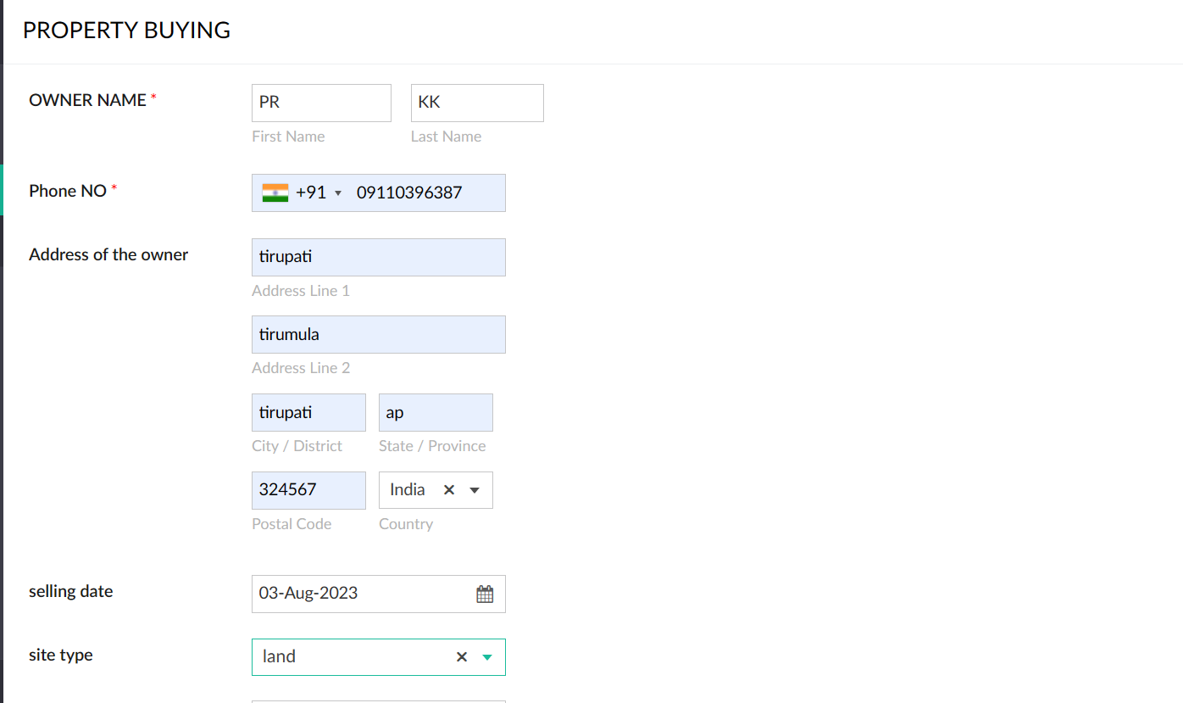

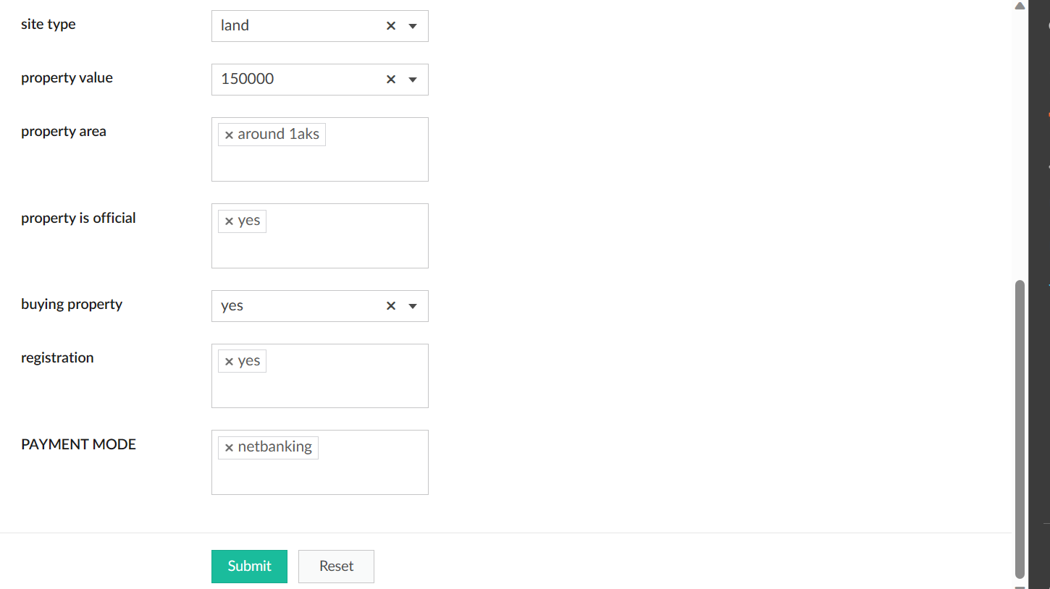

**OUTPUT:-**

